Salesforce/MSCRM – Data Management

**Objective:** Understand and apply data management techniques including import/export, deduplication, and data quality enforcement.

**Tasks:**

1. Use a sample CSV file to import at least 10 records into a custom object (e.g., 'Customer Feedback').
2. Create a data import template with required fields and validations.
3. Identify and remove duplicate entries using Salesforce Duplicate Rules or MSCRM Duplicate Detection.
4. Create validation rules to enforce data quality (e.g., mandatory contact details, date format check).
5. Export data from a report and validate data consistency.
6. Document data retention and backup strategy followed in your CRM instance.

**Deliverables:**

* Import template and record samples.
* Configuration of duplicate rules and validation rules.
* Data export file and validation summary.
* Brief on data management strategy.

Task 1: Use a sample CSV file to import at least 10 records into a custom object (e.g., 'Customer Feedback').

a. Go to app launcher and search for Data Import Wizard.

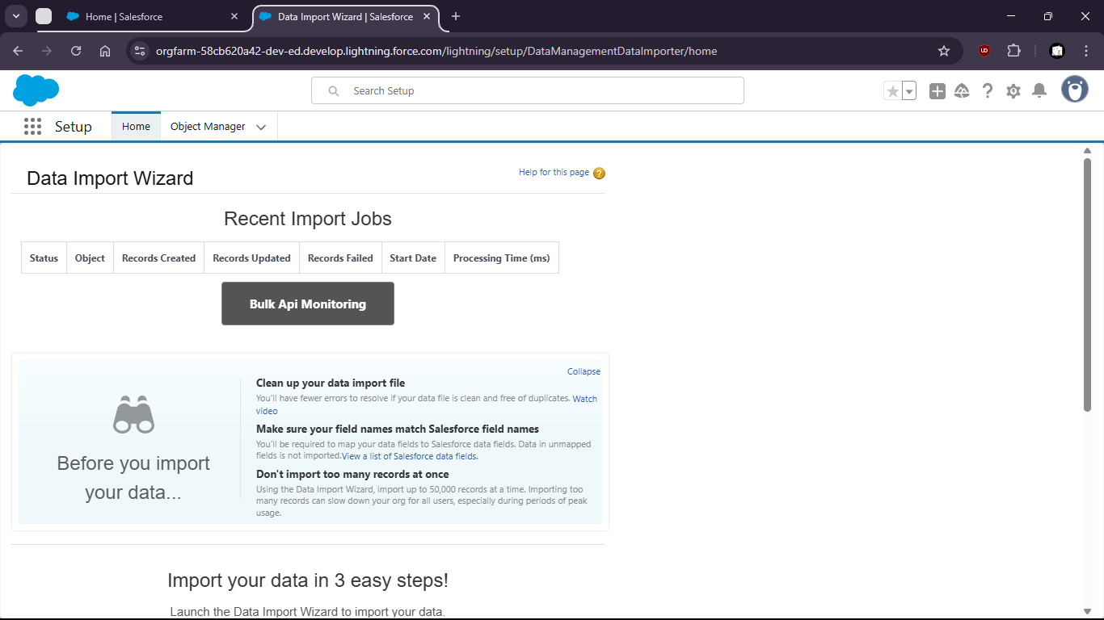

b. Launch the wizard

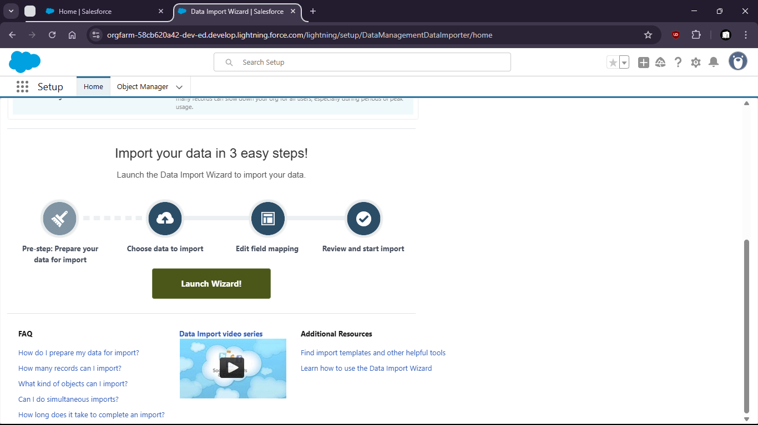

c. Upload the csv file.

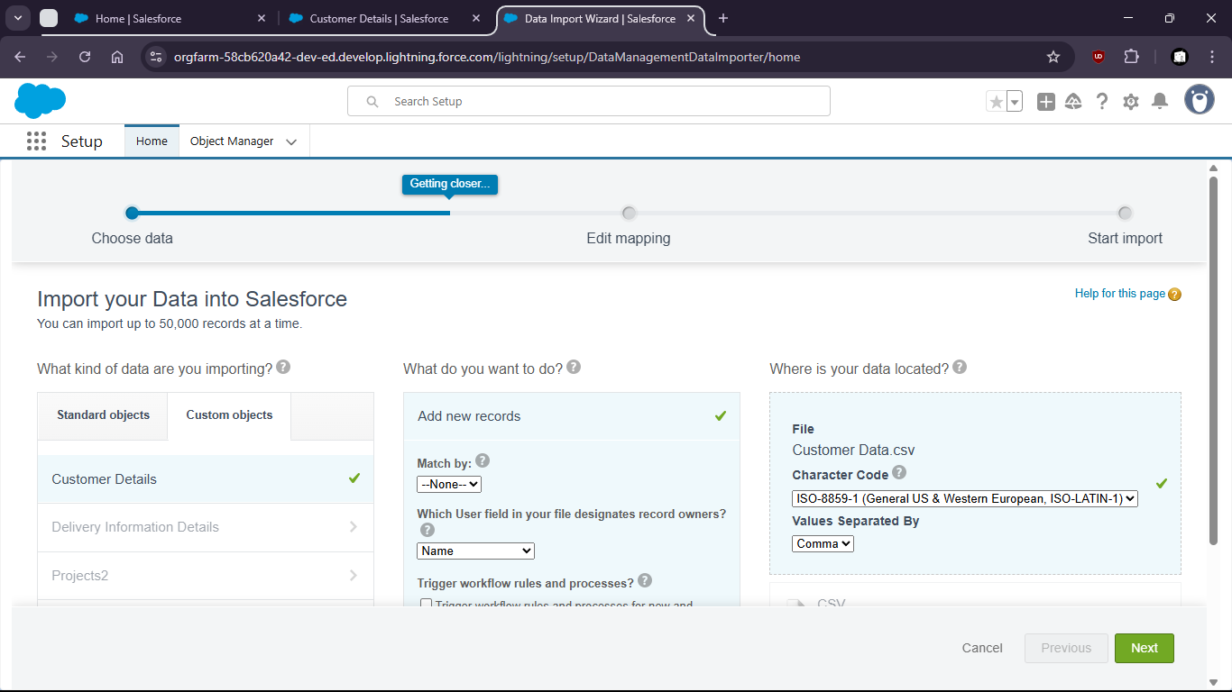

d. Map the fields

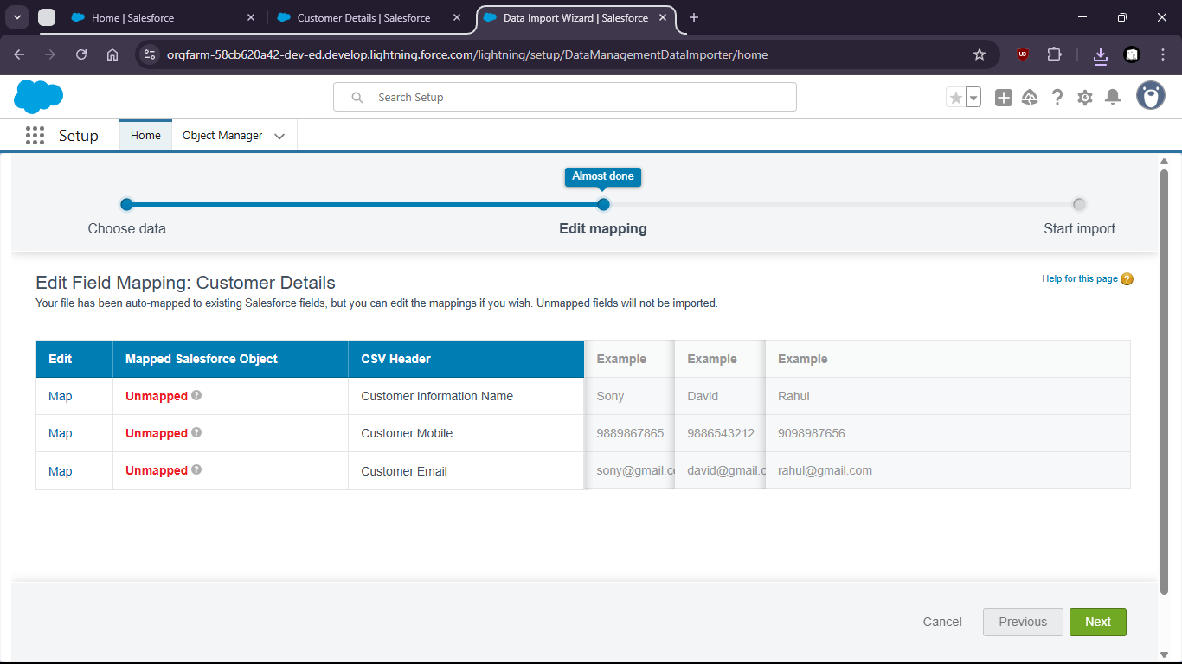

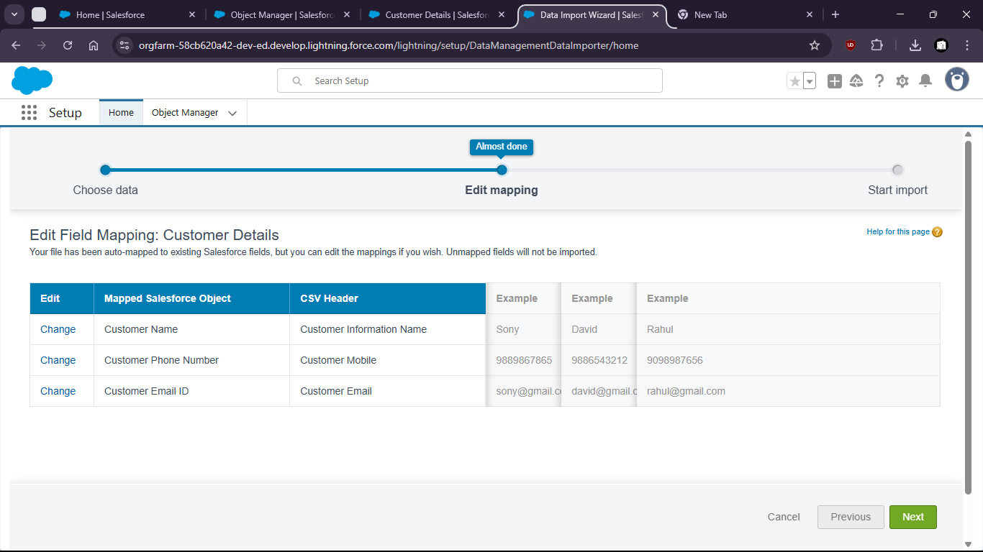

e. Start import.

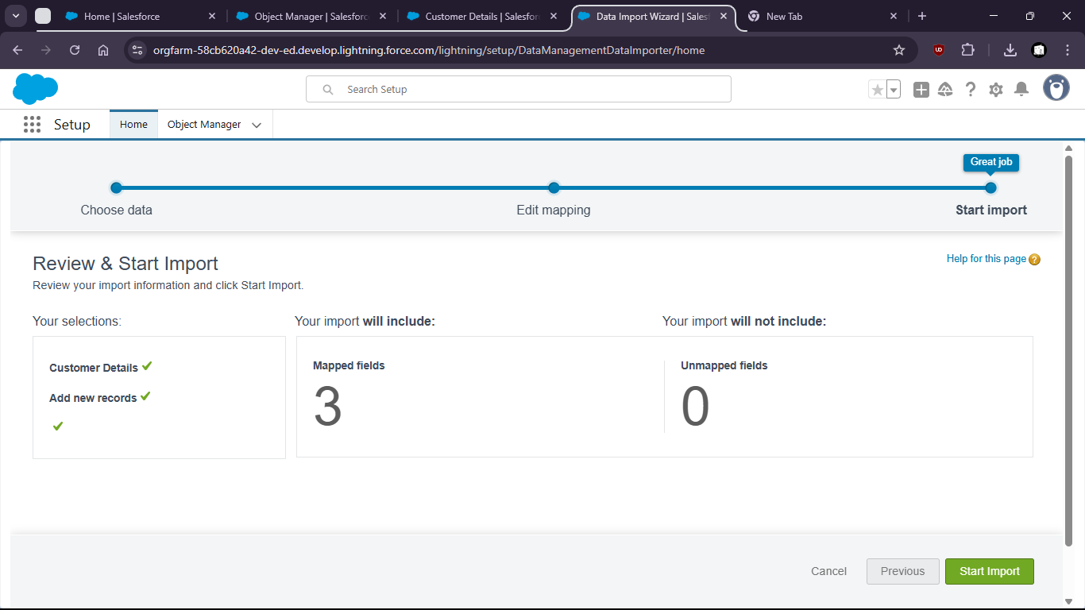

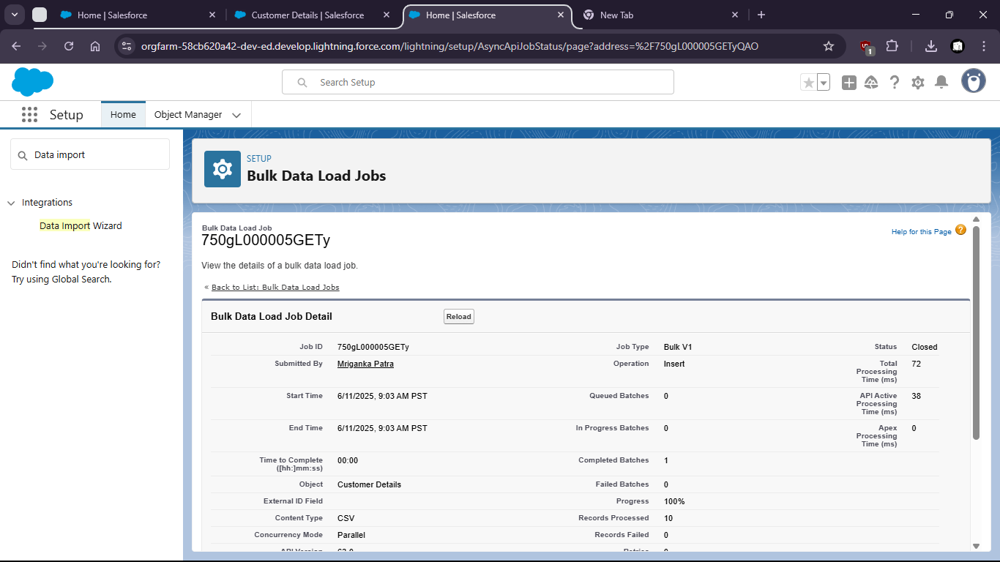

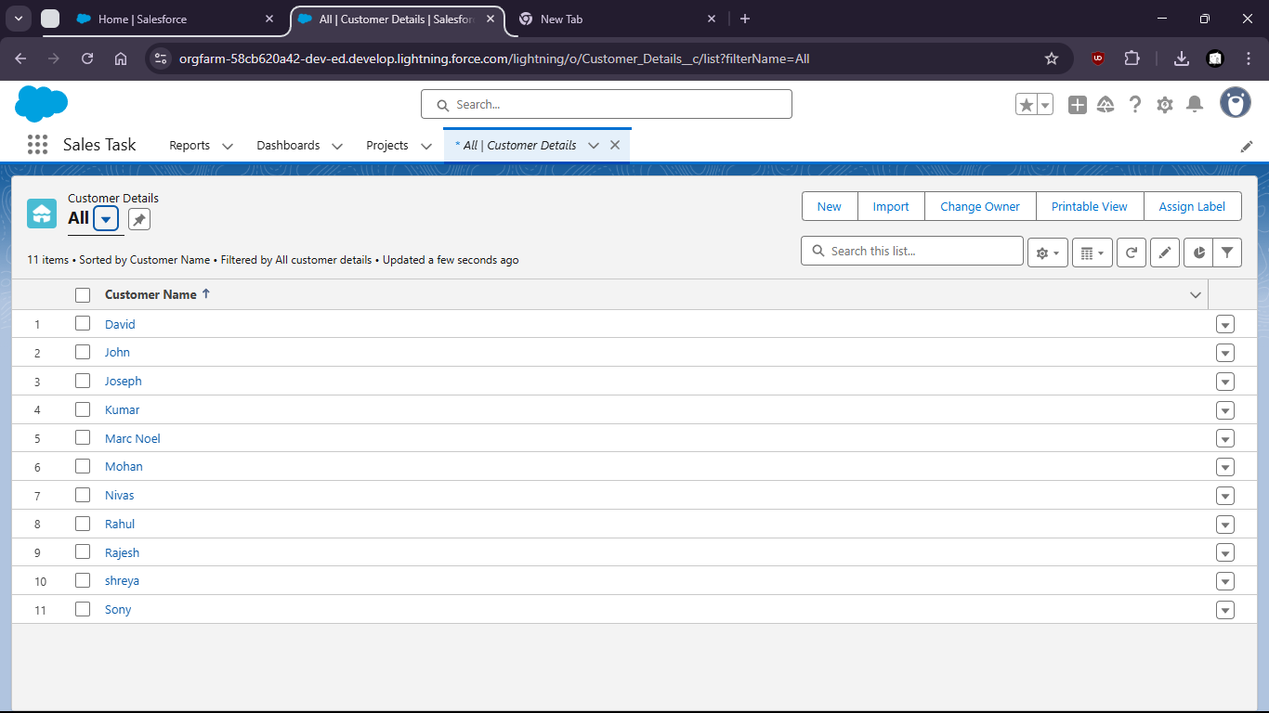

Task 2: Create a data import template with required fields and validations.

Task 3: Identify and remove duplicate entries using Salesforce Duplicate Rules or MSCRM Duplicate Detection.

a. Search for duplicate rules

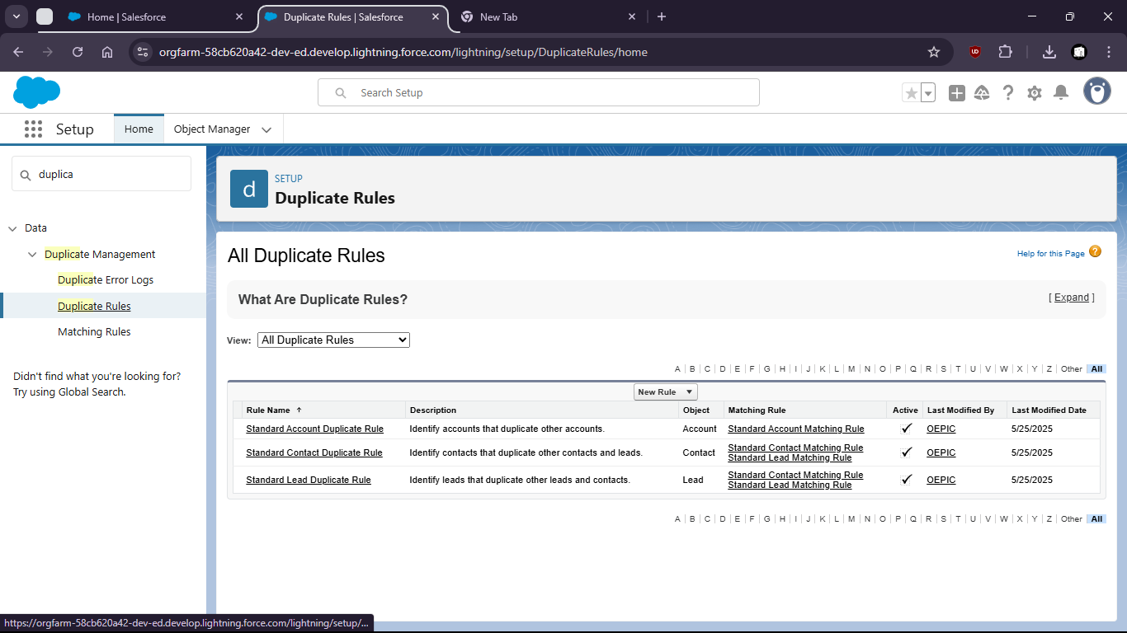

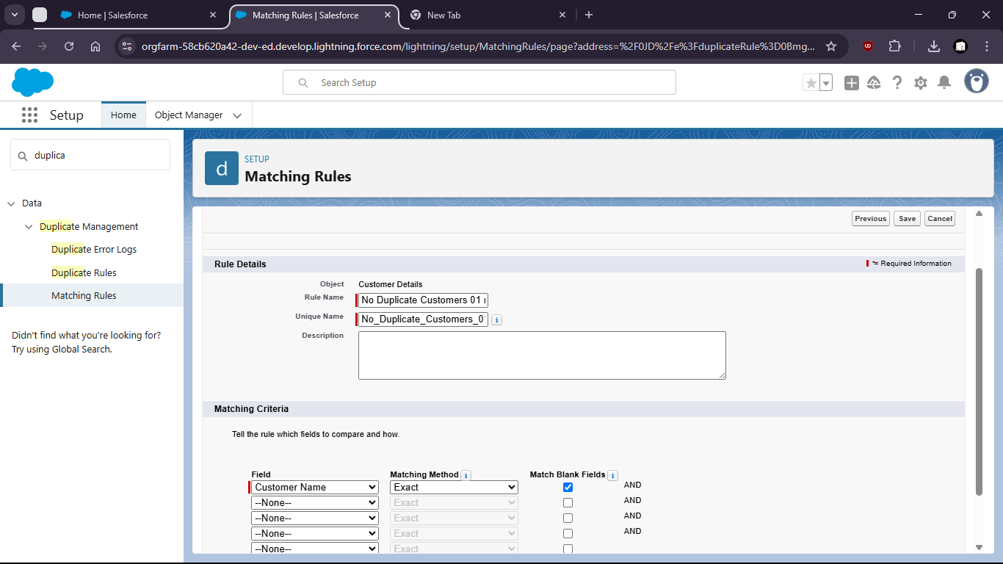

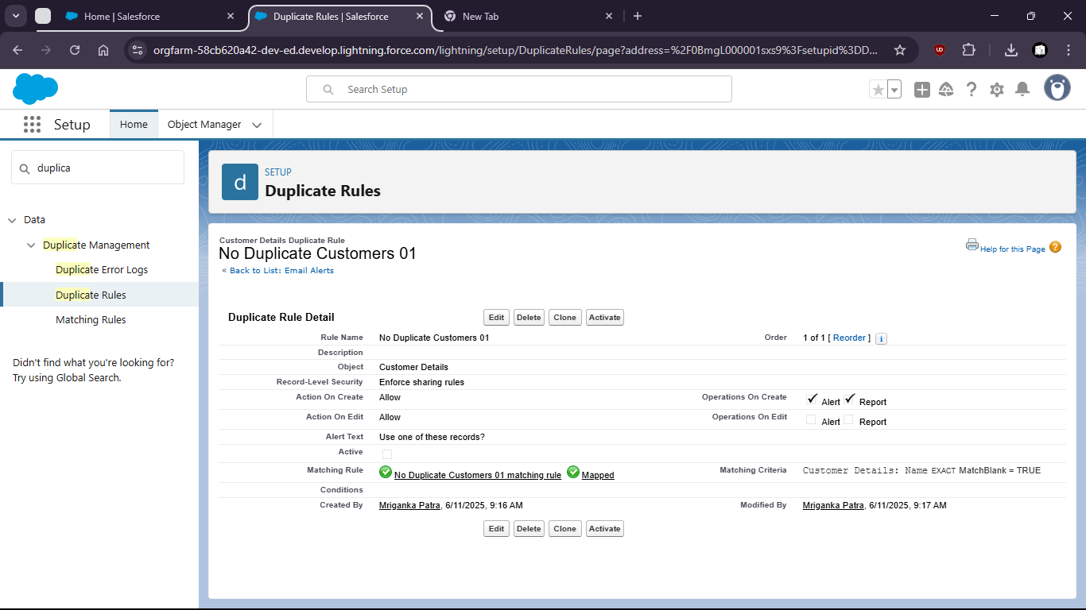

Task 4: Create validation rules to enforce data quality (e.g., mandatory contact details, date format check).

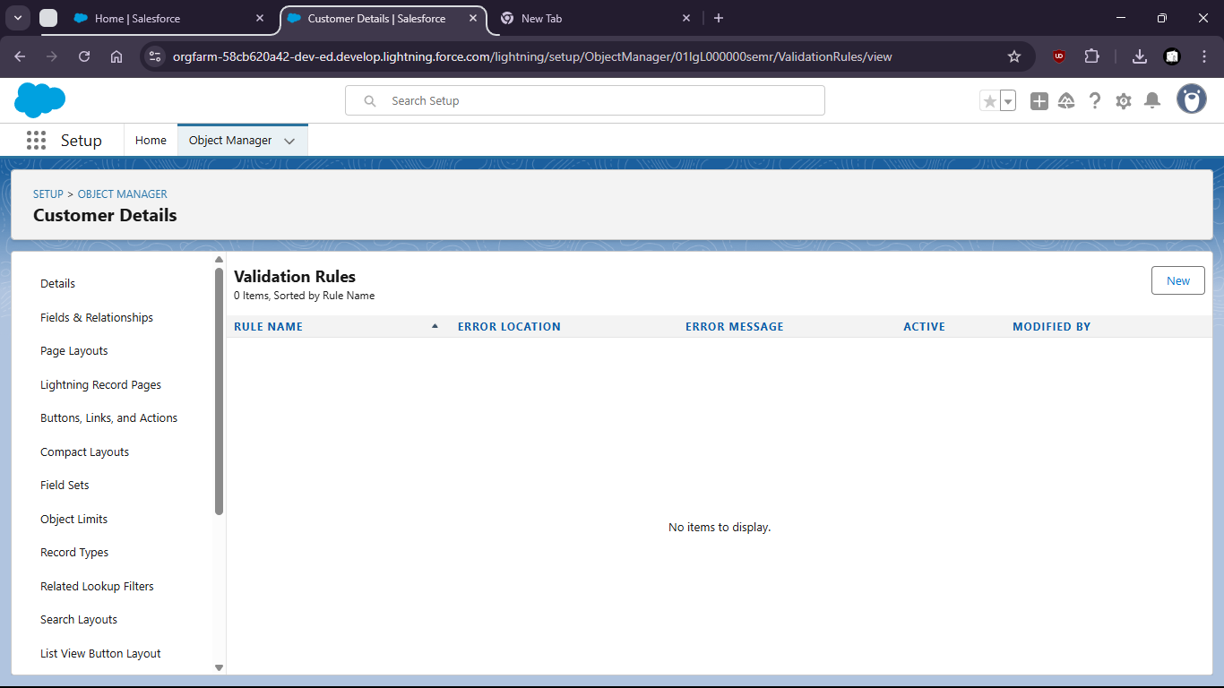

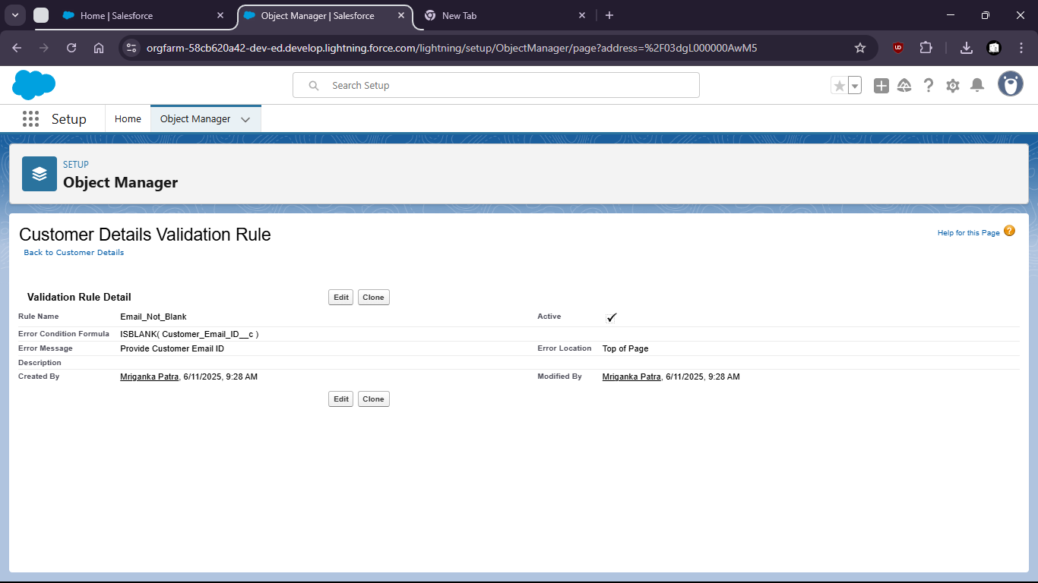

Task 5: Export data from a report and validate data consistency.

Task 6: Document data retention and backup strategy followed in your CRM instance.